**MINI PROJECT**

(15EMEP301)

**PEDAL OPERATED SHEET SHEARING MACHINE**

|  |  |  |  |
| --- | --- | --- | --- |
| **Name** | **Roll No** | **USN** | **Signature** |
| **Ajay Hiremath** | 228 | 01FE20BME170 |  |
| **Aayush Angadi** | 223 | 01FE20BME120 |  |
| **Neeraj Niranjan** | 214 | 01FE20BME039 |  |
| **Chetan Swaris** | 216 | 01FE20BME045 |  |
| **Raghavendra H** | 205 | 01FE20BME035 |  |
| **Allwin B** | 232 | 01FE21BME413 |  |

***TEAM B3***

|  |  |  |
| --- | --- | --- |
| SL NO | CONTENTS | PAGE NO |
| 1 | Acknowledgement | 3 |
| 2 | Introduction And Working Principle | 4 |
| 3 | Different types of Sheet Shearing Machine | 5 |
| 4 | Objectives And Functions Of Pedal Operated Sheet Shearing Machine | 6 |
| 5 | Advantages And Disadvantages Of Pedal Operated Sheet Shearing Machine | 7 |
| 6 | Specification of pedal operated sheet Shearing Machine | 8 |
| 7 | Bill Of Materials (BOM) | 9 |
| 8 | 2-D Drawings | 10-13 |
| 9 | 3D MODEL’S | 14-24 |
| 10 | 3-D Assembly | 25-29 |
| 11 | Drafting | 30-42 |
| 12 | Exploded view | 43 |
| 13 | Ballooning | 44 |
| 14 | Rendered View | 45 |

**ACKNOWLEDGEMENT**

The pleasure that follows the successful completion of our mini-project would remain incomplete without a word of gratitude to every single person who has contributed help for the completion of our mini-project.

We are grateful to have **Prof Umesh P Hosmani** as our course instructor and express our sincere gratitude for his motivation, inspiration, guidance, and support during the completion of the mini- project. His words of encouragement and unconditional dedication will always be cherished.

We are thankful to our department for providing all the necessary materials for experimenting. We would like to acknowledge all lectures of our department for their continuous support in carrying out the project. We thank all the non-teaching staff, lab instructors, and lab associates who helped us throughout the project.

**Introduction And Working Principle**

A pedal operated sheet shearing machine is a mechanical device used to cut sheets of metal, plastic, or other materials into precise sizes and shapes. It is a hand-powered machine that is operated by a person using their feet to press down on pedals, which in turn activates the cutting blade. This type of machine is commonly used in fabrication and manufacturing settings, as well as in automotive repair and maintenance shops. It is a versatile tool that can be used to cut a wide range of materials, including steel, aluminium, brass, and copper.

The pedal operated sheet shearing machine is a safe and efficient way to make precise cuts, and it is an essential tool for many types of manufacturing and repair work. It is a simple and cost-effective alternative to larger, more expensive cutting machines, and it can be easily moved and stored when not in use. It is also a relatively quiet machine, making it suitable for use in a variety of settings.

The basic principle behind the pedal operated sheet shearing machine is the use of a cutting blade to slice through the material being cut. The cutting blade is mounted on a long arm, which is attached to a pivot point at one end. When the pedals are pressed down, the cutting blade is forced downward, slicing through the material as it moves. The blade is held in place by a clamping mechanism, which keeps it secure and prevents it from slipping during the cutting process.

There are several different types of pedal operated sheet shearing machines available on the market, each designed for specific applications. Some machines are designed for use in a workshop or factory setting, while others are portable and can be carried to different locations. There are also specialized machines for cutting specific materials, such as aluminium or stainless steel.

One of the main advantages of the pedal operated sheet shearing machine is its simplicity and ease of use. It is a relatively simple machine, with few moving parts, which makes it easy to maintain and repair. It is also relatively easy to learn how to use, with most people able to master the basic operation within a short period of time. This makes it a popular choice for many small businesses and workshop owners who need a reliable and cost-effective cutting solution.

The main goal of this project is reverse engineering, learning how to assemble mechanical parts and how to modify them in the assembly. You can learn how things are arranged/fixed in the final product and you can learn how to create his 3D models of parts and incorporate them into the product.

**Different types of Sheet Shearing Machine**

1. Hand-held shears: These are small, portable machines that can be easily carried to different locations. They are typically used for cutting thin sheets of metal or plastic, and they are well-suited for making precise cuts in tight spaces.
2. Bench-mounted shears: These are larger machines that are designed to be used on a workbench or table. They are typically more powerful than hand-held shears, and they are capable of cutting thicker sheets of material.
3. Guillotine shears: These are heavy-duty machines that are designed for cutting large sheets of metal or other materials. They are typically used in industrial or manufacturing settings, and they are equipped with powerful cutting blades and sturdy clamping mechanisms.
4. Specialized shears: There are also specialized shears available for cutting specific materials, such as aluminium or stainless steel. These machines are designed with the specific properties of the material in mind, and they are equipped with specialized cutting blades and clamping mechanisms to ensure accurate and efficient cutting.
5. Hydraulic shears: These are high-powered machines that use hydraulic pressure to operate the cutting blade. They are typically used in industrial or manufacturing settings, and they are capable of cutting thicker sheets of material with greater precision and accuracy.
6. Motorized shears: Some pedal operated sheet shearing machines are equipped with electric motors, which provide additional power and speed. These machines are typically more expensive than hand-powered models, but they are also more efficient and capable of cutting thicker sheets of material.

**Objectives And Functions Of Pedal Operated Sheet Shearing Machine**

1. **To cut sheets of metal, plastic, or other materials into precise sizes and shapes.**
2. **To provide a cost-effective and efficient alternative to larger, more expensive cutting machines.**
3. **To be easy to use and maintain, with few moving parts and simple operation.**
4. **To be safe to use, with minimal risk of injury or accidents.**
5. **To be versatile and able to cut a wide range of materials, including steel, aluminum, brass, and copper.**
6. **To be portable and easy to store when not in use.**
7. **To be suitable for use in a variety of settings, including workshops, factories, and automotive repair shops.**
8. **To be a reliable and cost-effective tool for making precise cuts in a variety of materials.**

**Advantages And Disadvantages Of Pedal Operated Sheet Shearing Machine**

Advantages

1. It is a cost-effective and efficient alternative to larger, more expensive cutting machines.
2. It is simple to use and easy to maintain, with few moving parts and simple operation.
3. It is safe to use, with minimal risk of injury or accidents.
4. It is versatile and able to cut a wide range of materials, including steel, aluminium, brass, and copper.
5. It is portable and easy to store when not in use.
6. It is suitable for use in a variety of settings, including workshops, factories, and automotive repair shops.
7. It is a reliable and cost-effective tool for making precise cuts in a variety of materials.

Disadvantages

1. It may not be powerful enough to cut thicker sheets of material.
2. It requires manual operation, which can be tiring for the operator over long periods of use.
3. It may not be suitable for high-volume production environments, as it is slower than larger, motorized cutting machines.
4. It may not be suitable for cutting materials that require very precise cuts, as it relies on the operator's strength and precision.
5. It may be more difficult to find replacement parts or repair technicians if the machine breaks down or requires maintenance.

**SPECIFICATION OF PEDAL OPERATED SHEET SHEARING MACHINE**

|  |  |
| --- | --- |
| * Cutting Material | Iron Sheet, Copper Sheet |
| * Operation Mode | Manual |
| * Max Shear Width | 1mm To 40-inch |
| * Body Material | Cast Iron |
| * Cutting Capacity | 1MM(20SWG) |

**Original Product**

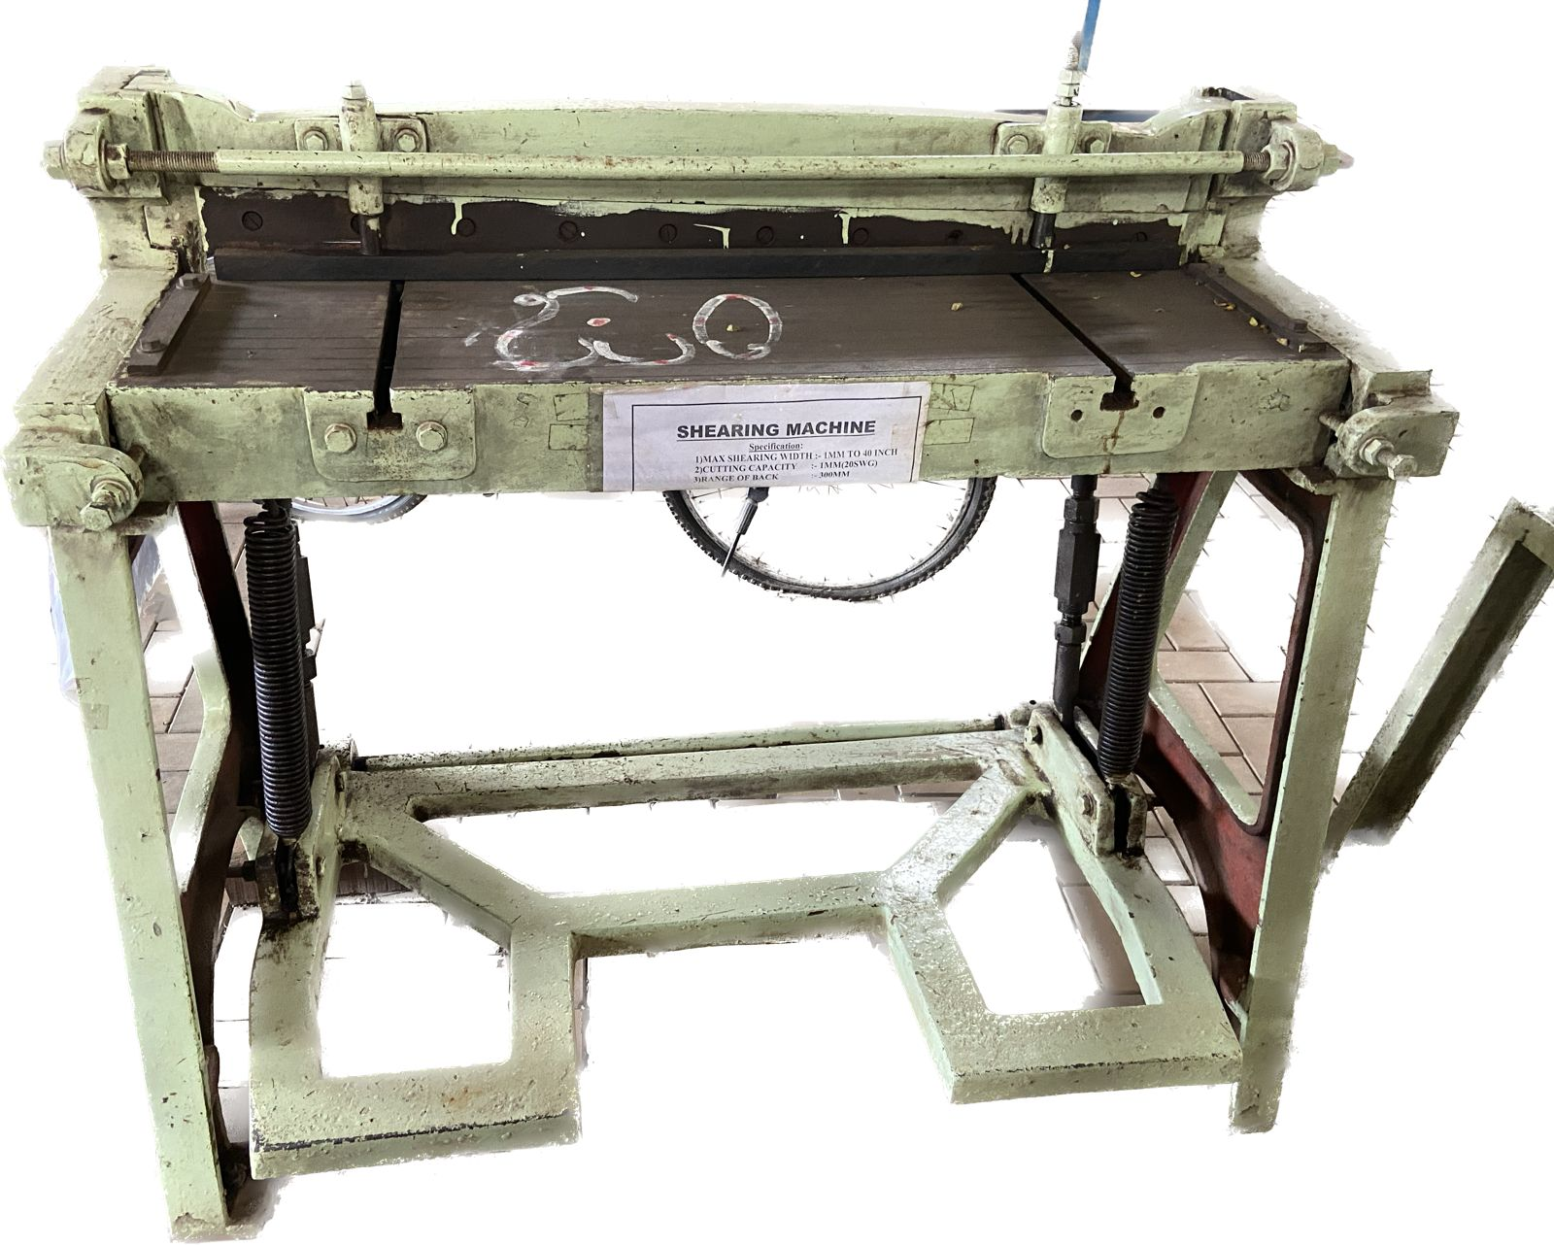

**Bill Of Materials (BOM)**

|  |  |  |
| --- | --- | --- |
| Sl.No. | Parts | Quantity |
| 1 | Spring | 2 |
| 2 | Pedal | 1 |
| 3 | Back support | 1 |
| 4 | T Slot | 2 |
| 5 | Side support | 1 |
| 6 | L clamp for back support | 2 |
| 7 | Spring rod | 2 |
| 8 | Side support | 2 |
| 9 | Front support rod | 1 |
| 10 | Front support | 2 |
| 11 | M12 Screws | 24 |
| 12 | M10 Screws | 6 |

**2-D Drawings**

STAND

PEDAL

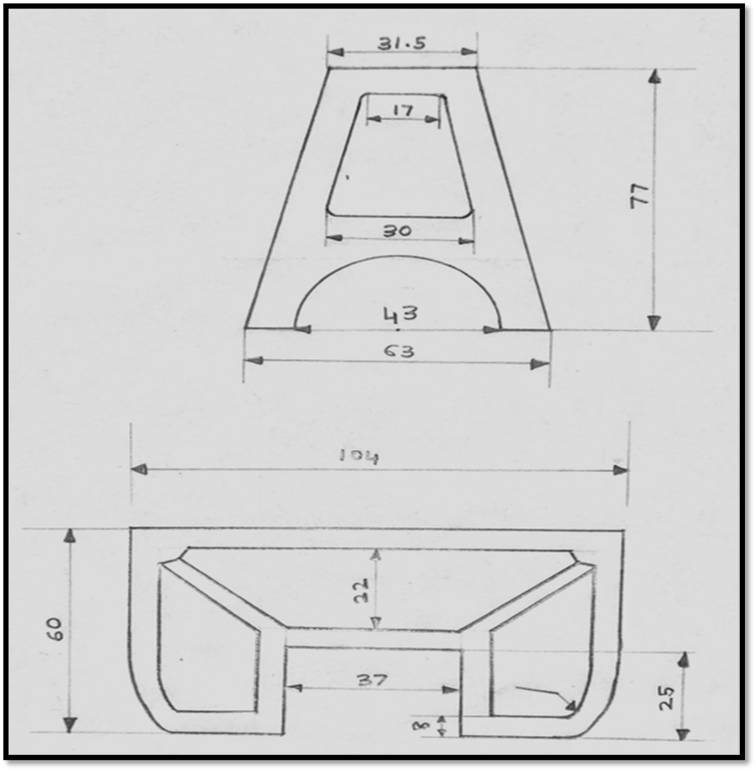

FRONT STAND

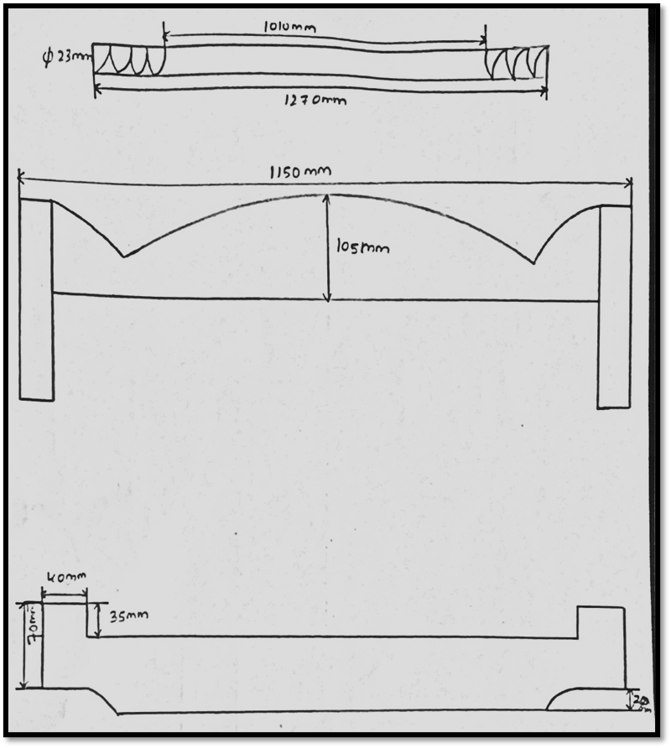

BED

PEDAL ROD

FRONT SUPPORT

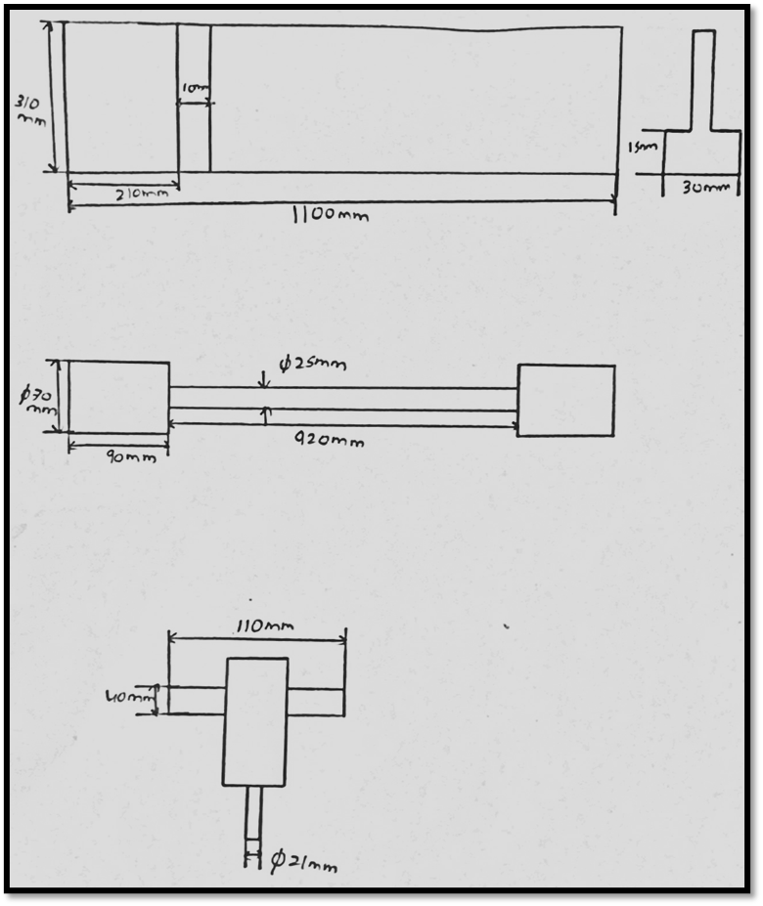

BACK SUPPORT CLIP

SIDE SUPPORT

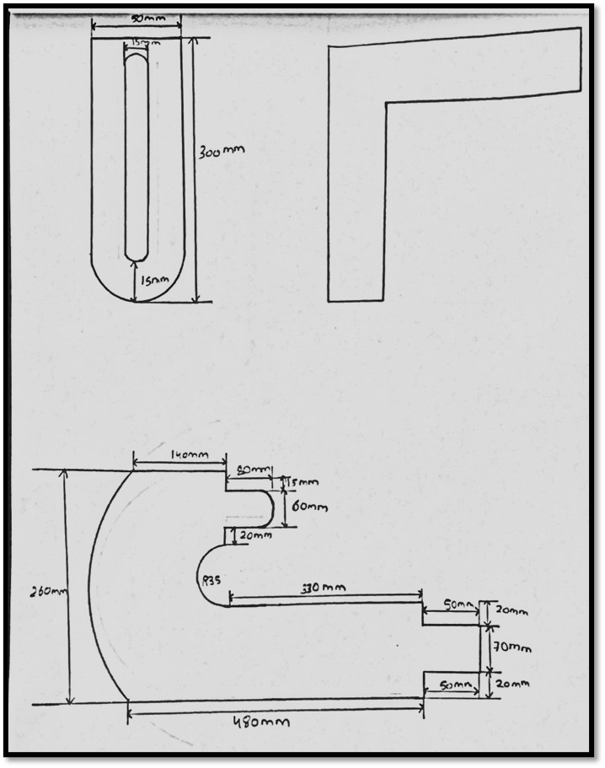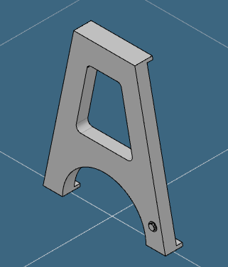

**3D MODEL’S**

STAND

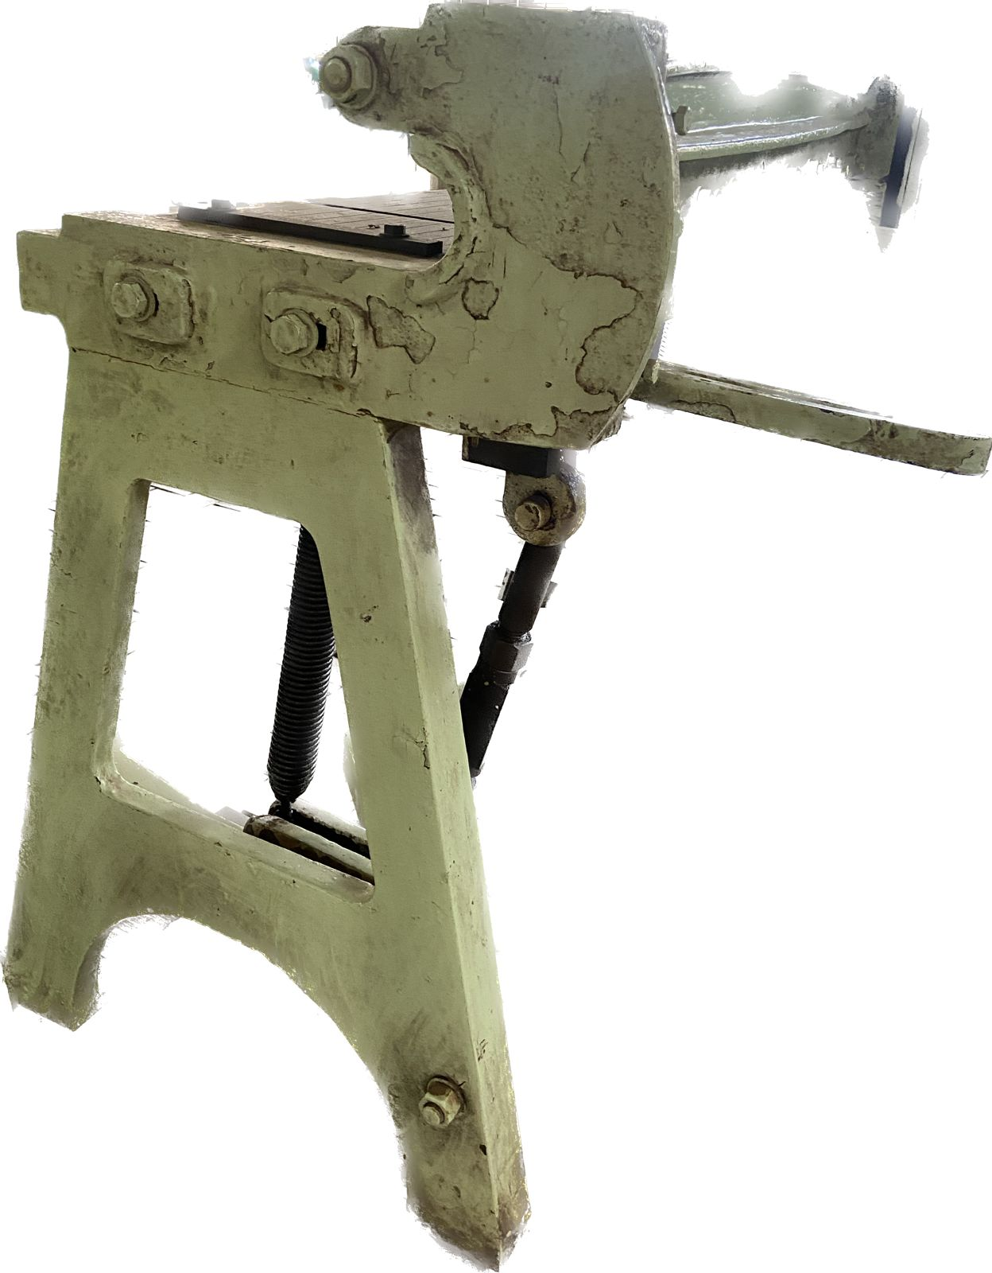

PEDAL

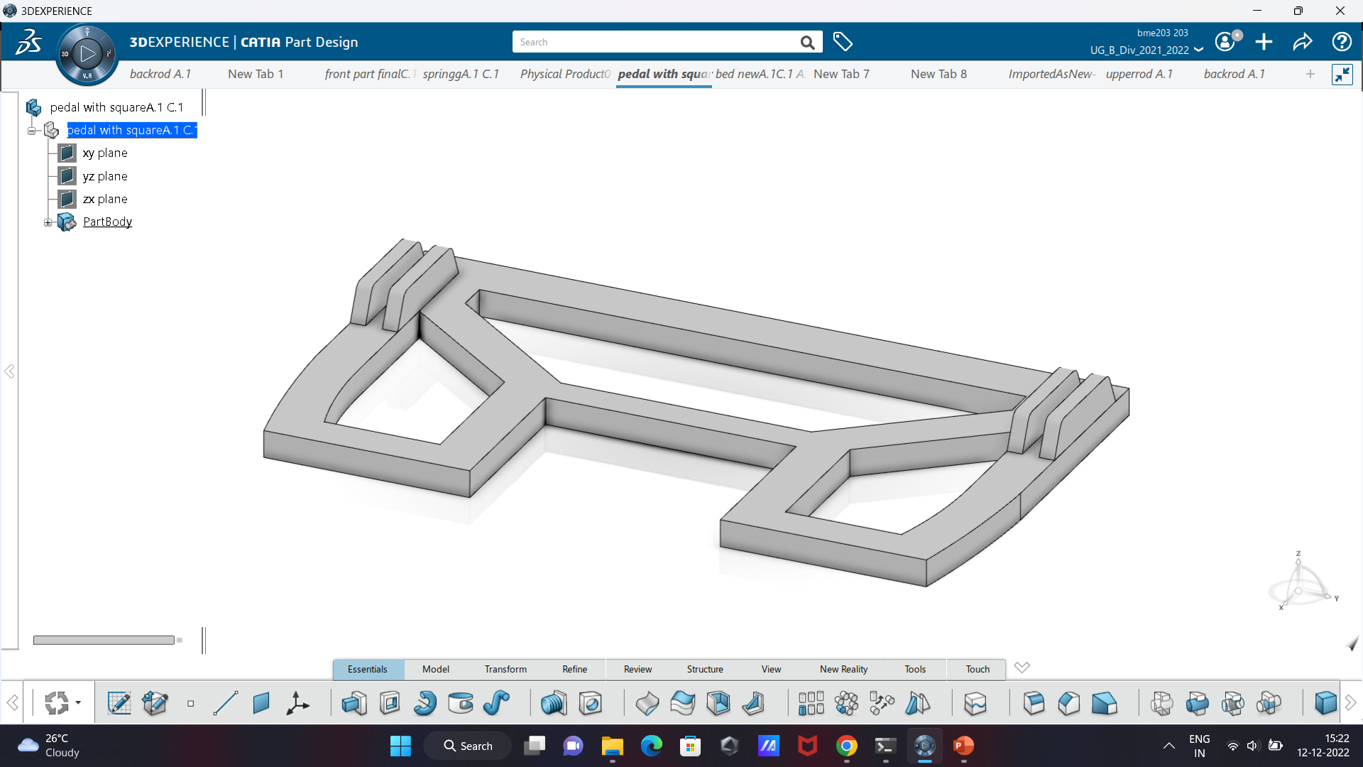

BACK SUPPORT CLIP

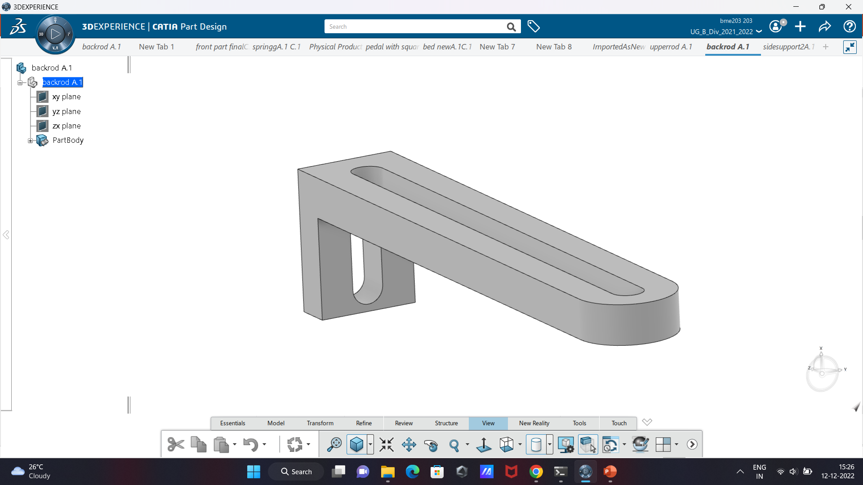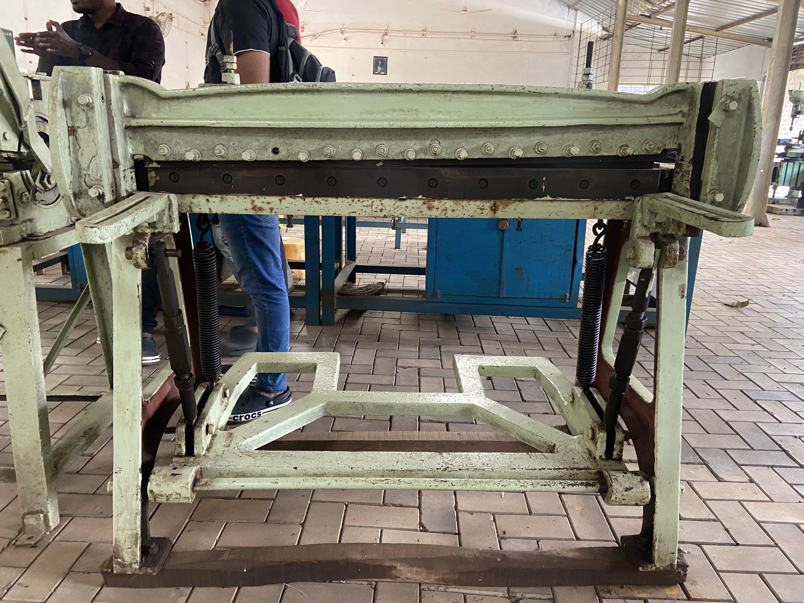

SIDE SUPPORT

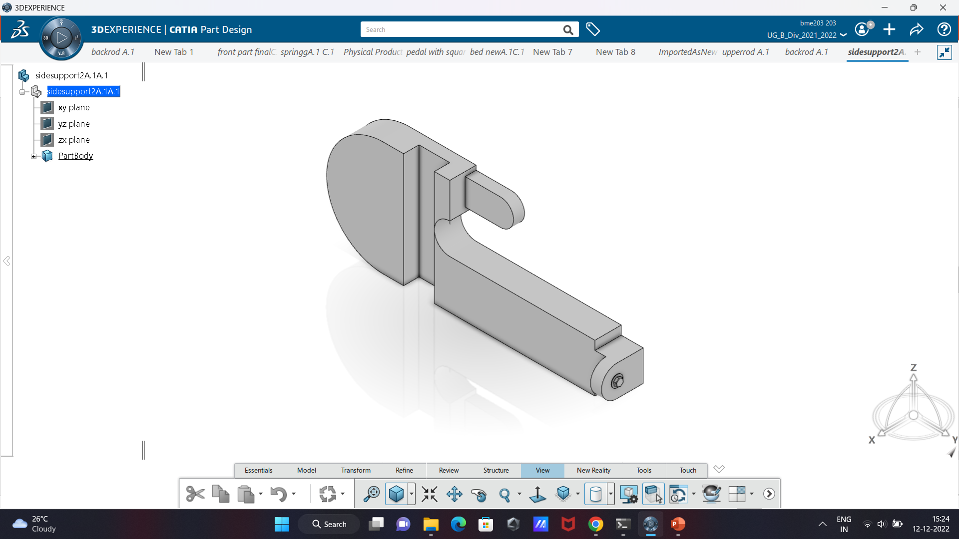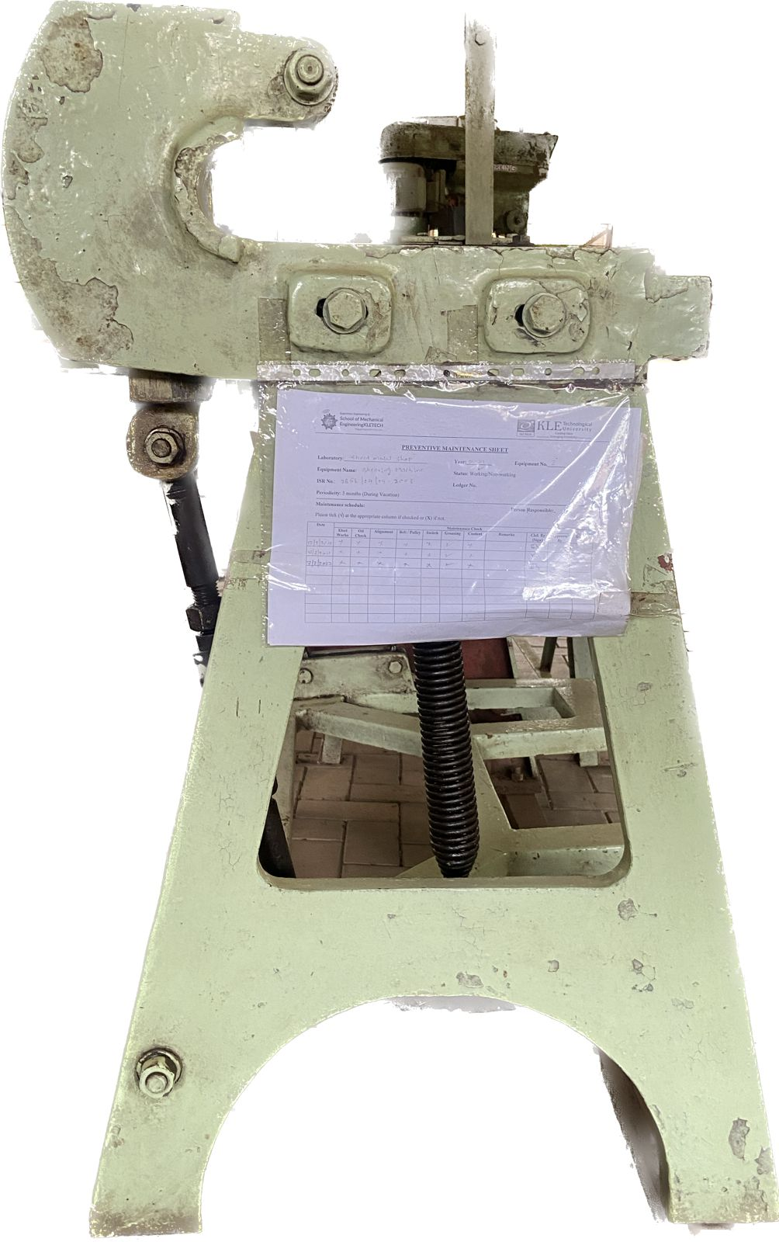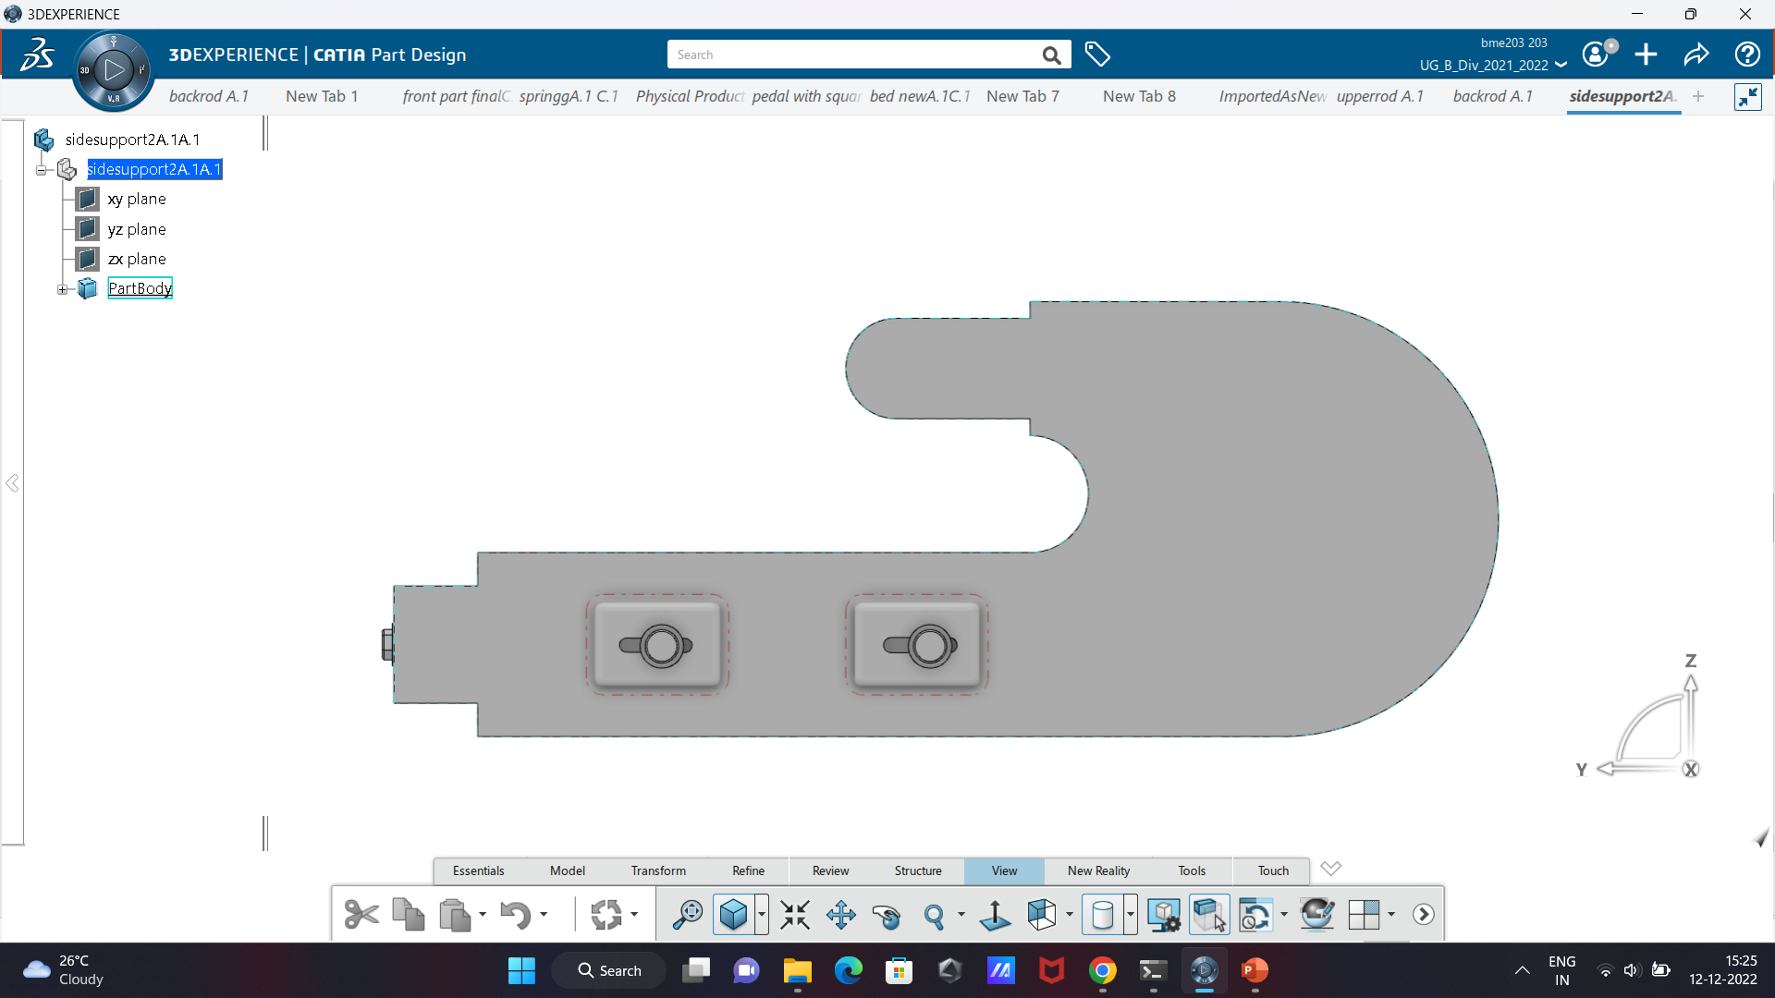

BED

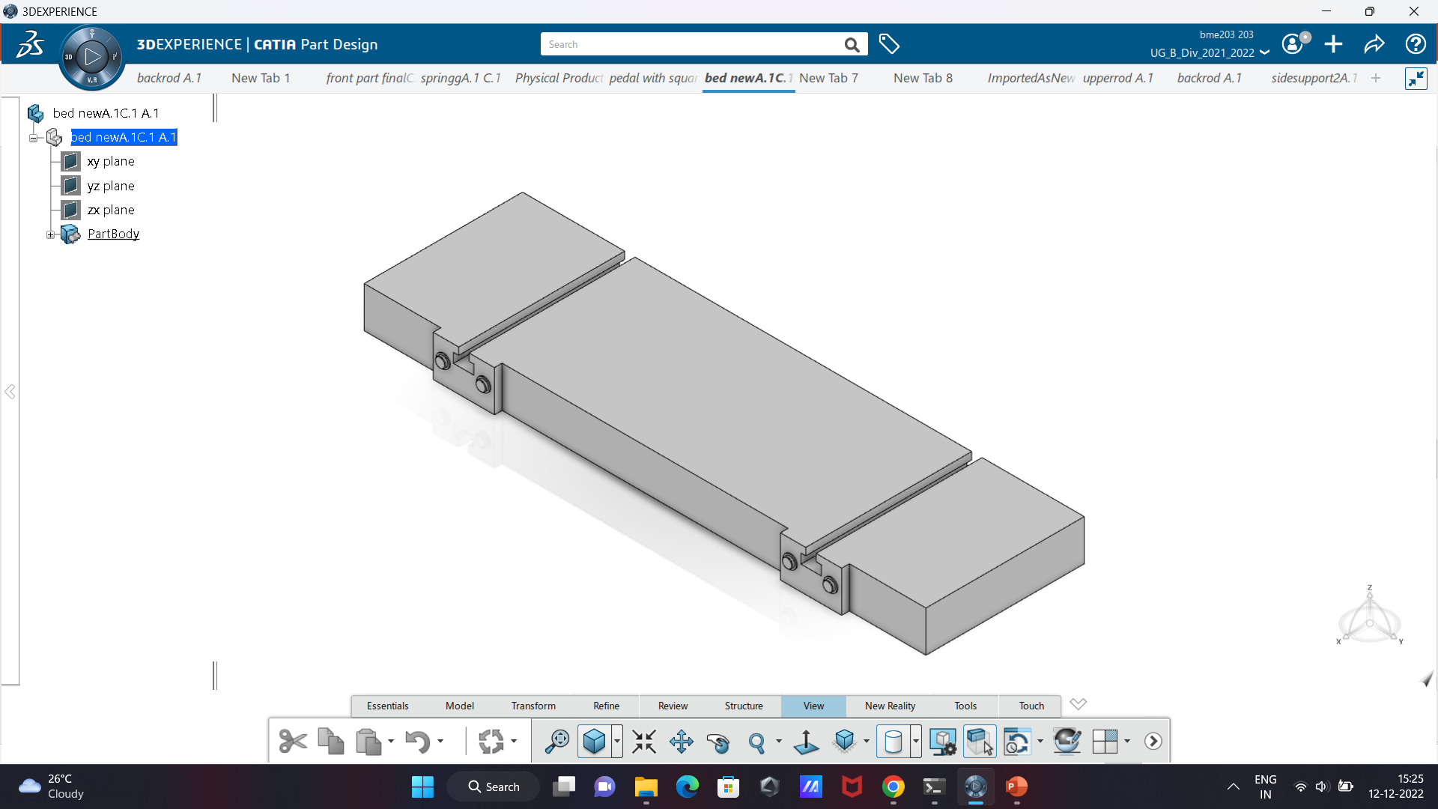

PEDAL ROD

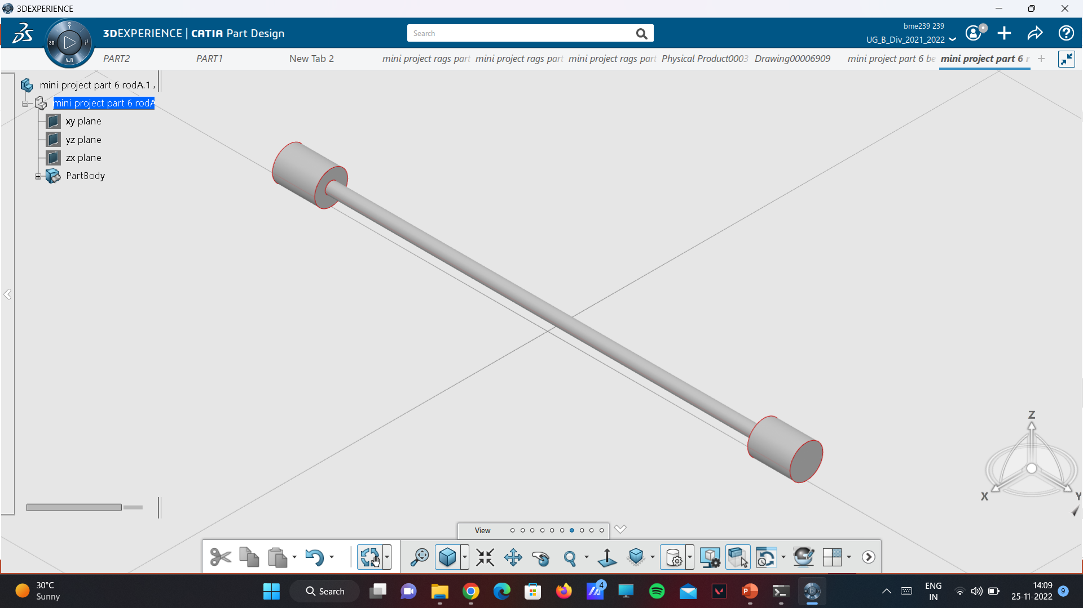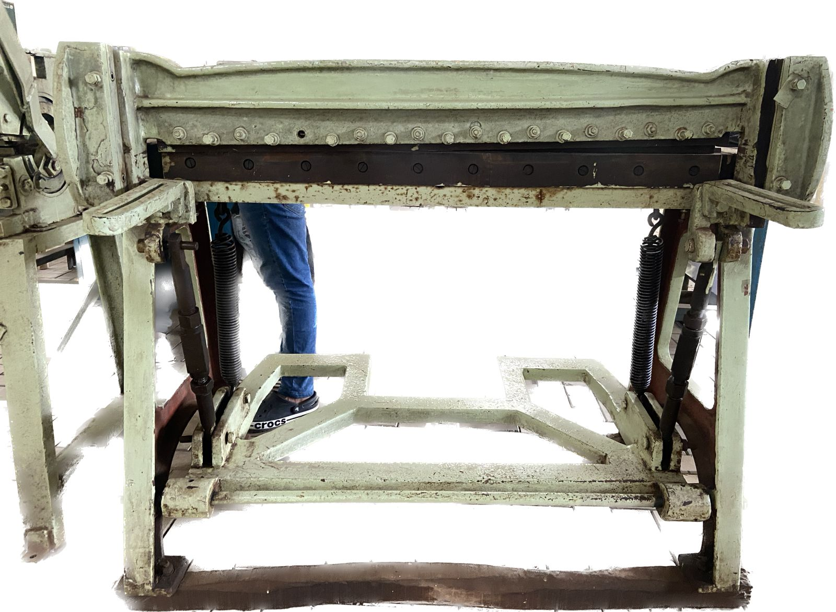

FRONT STAND SUPPORT

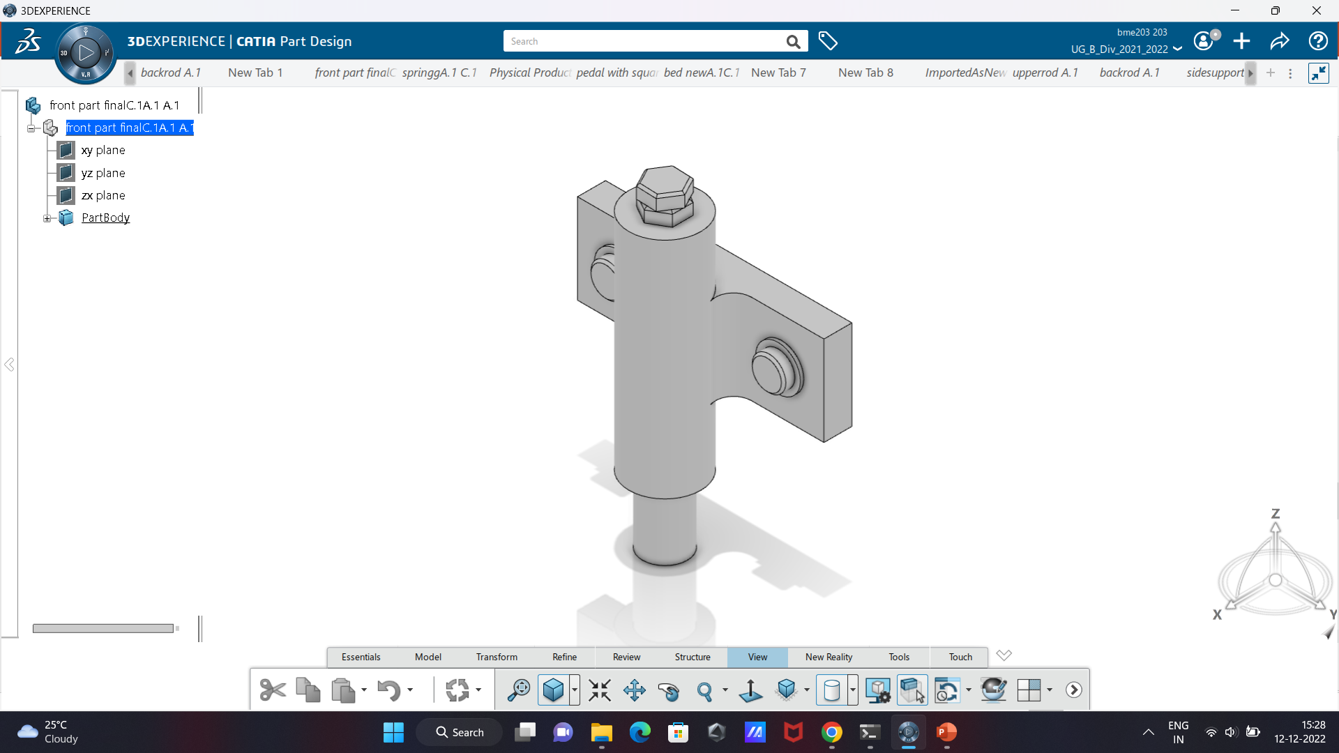

SPRING

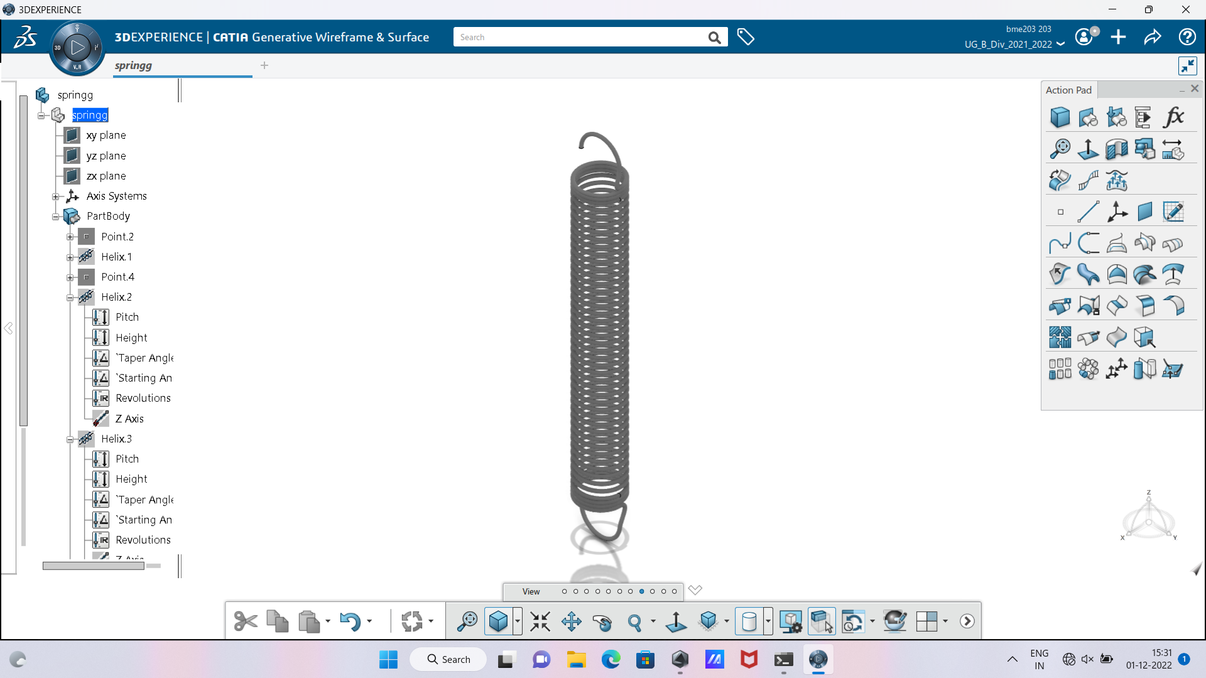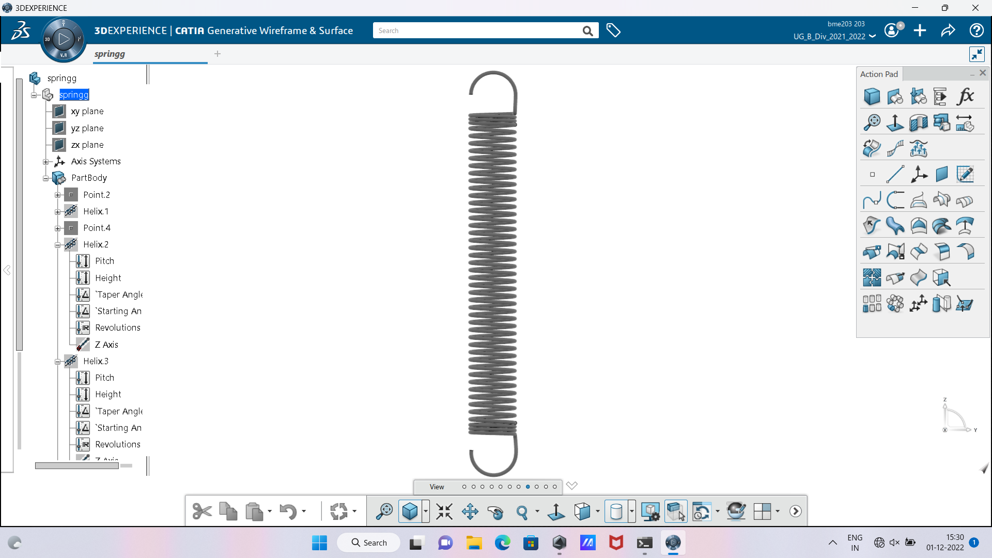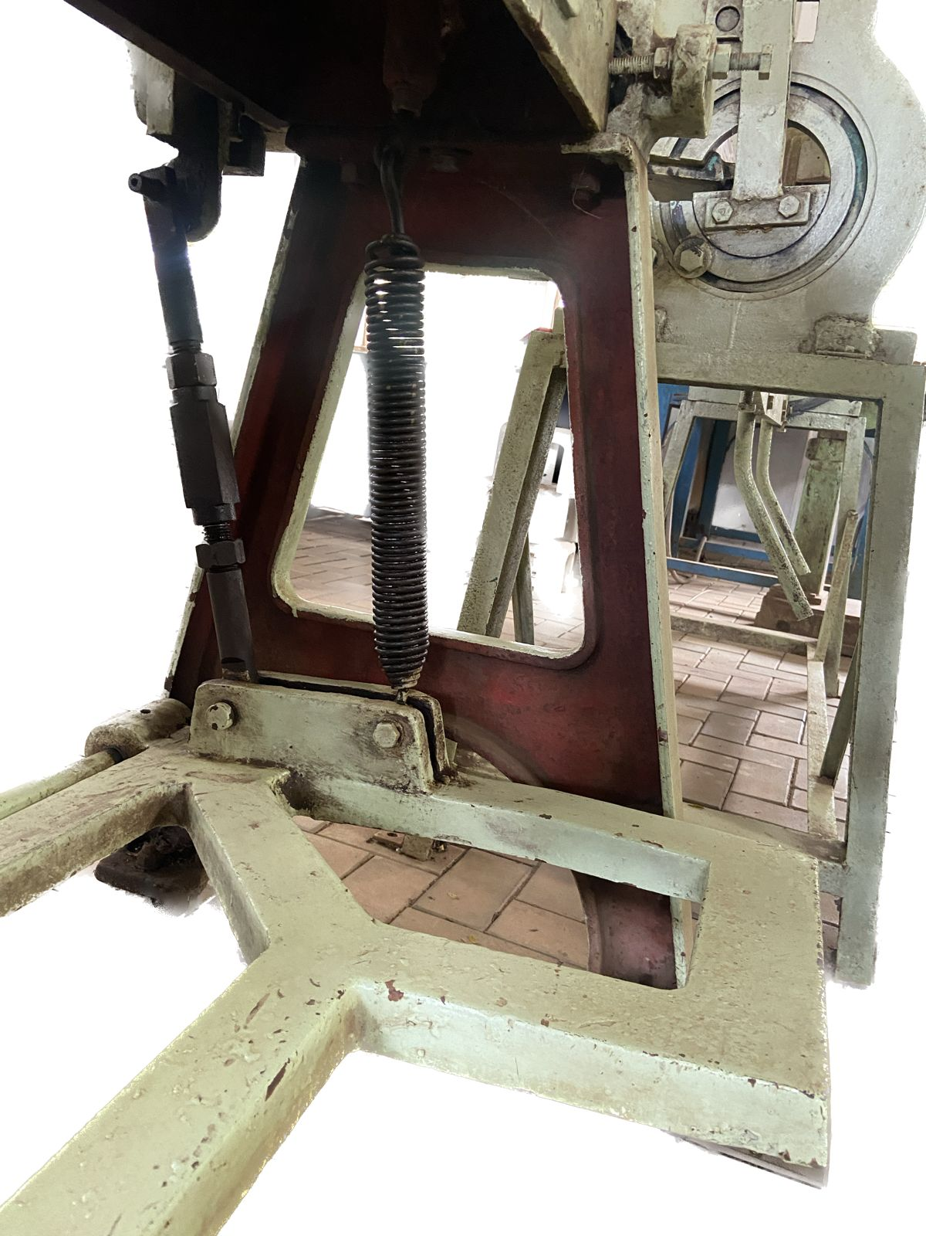

SPRING SUPPORT ROD

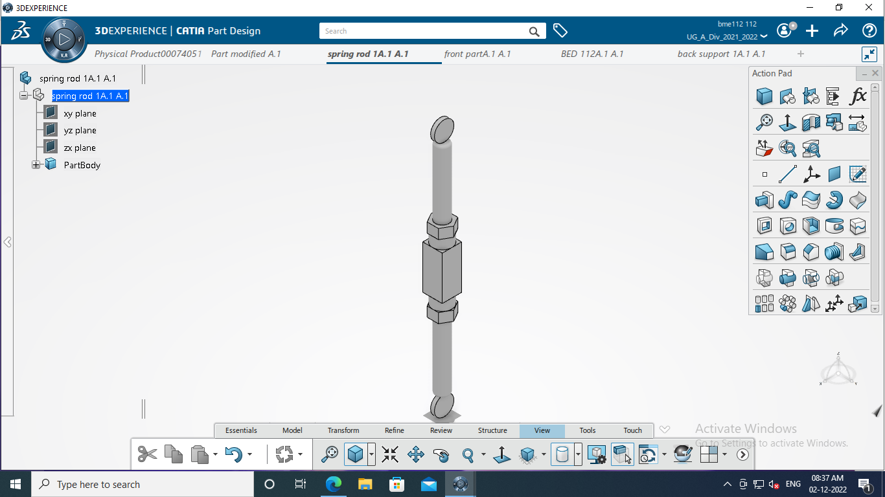

FRONT SUPPORT

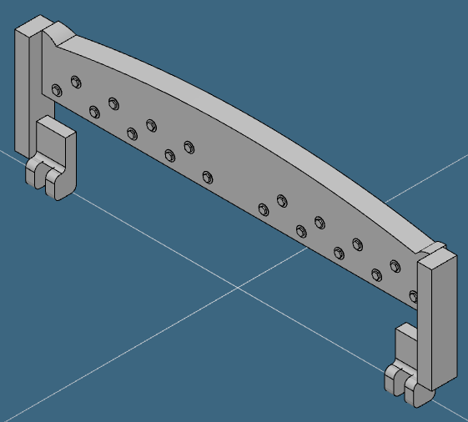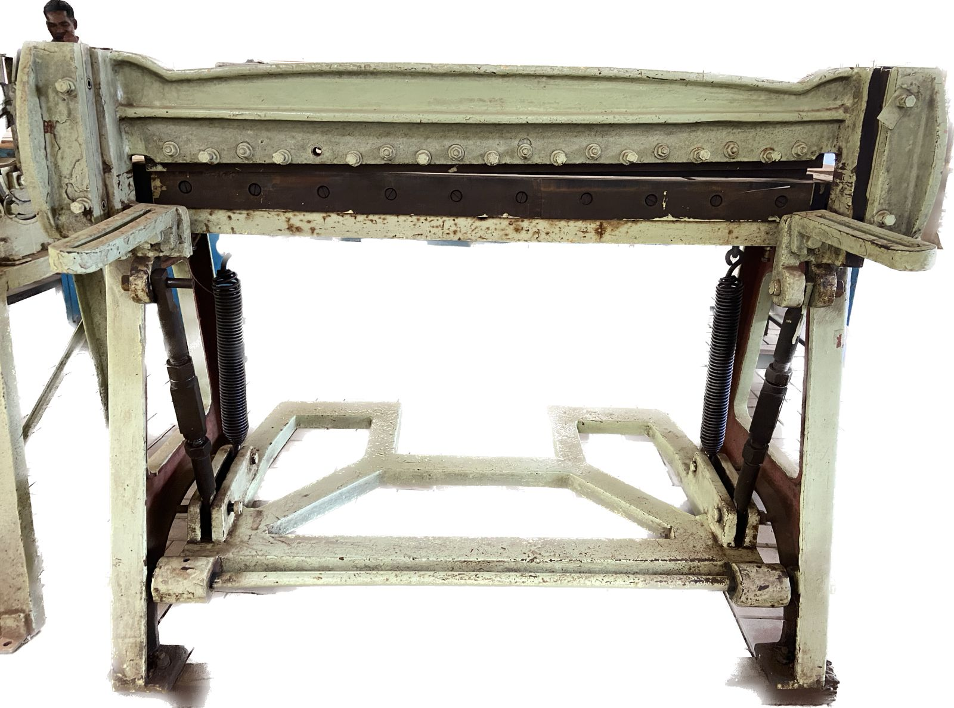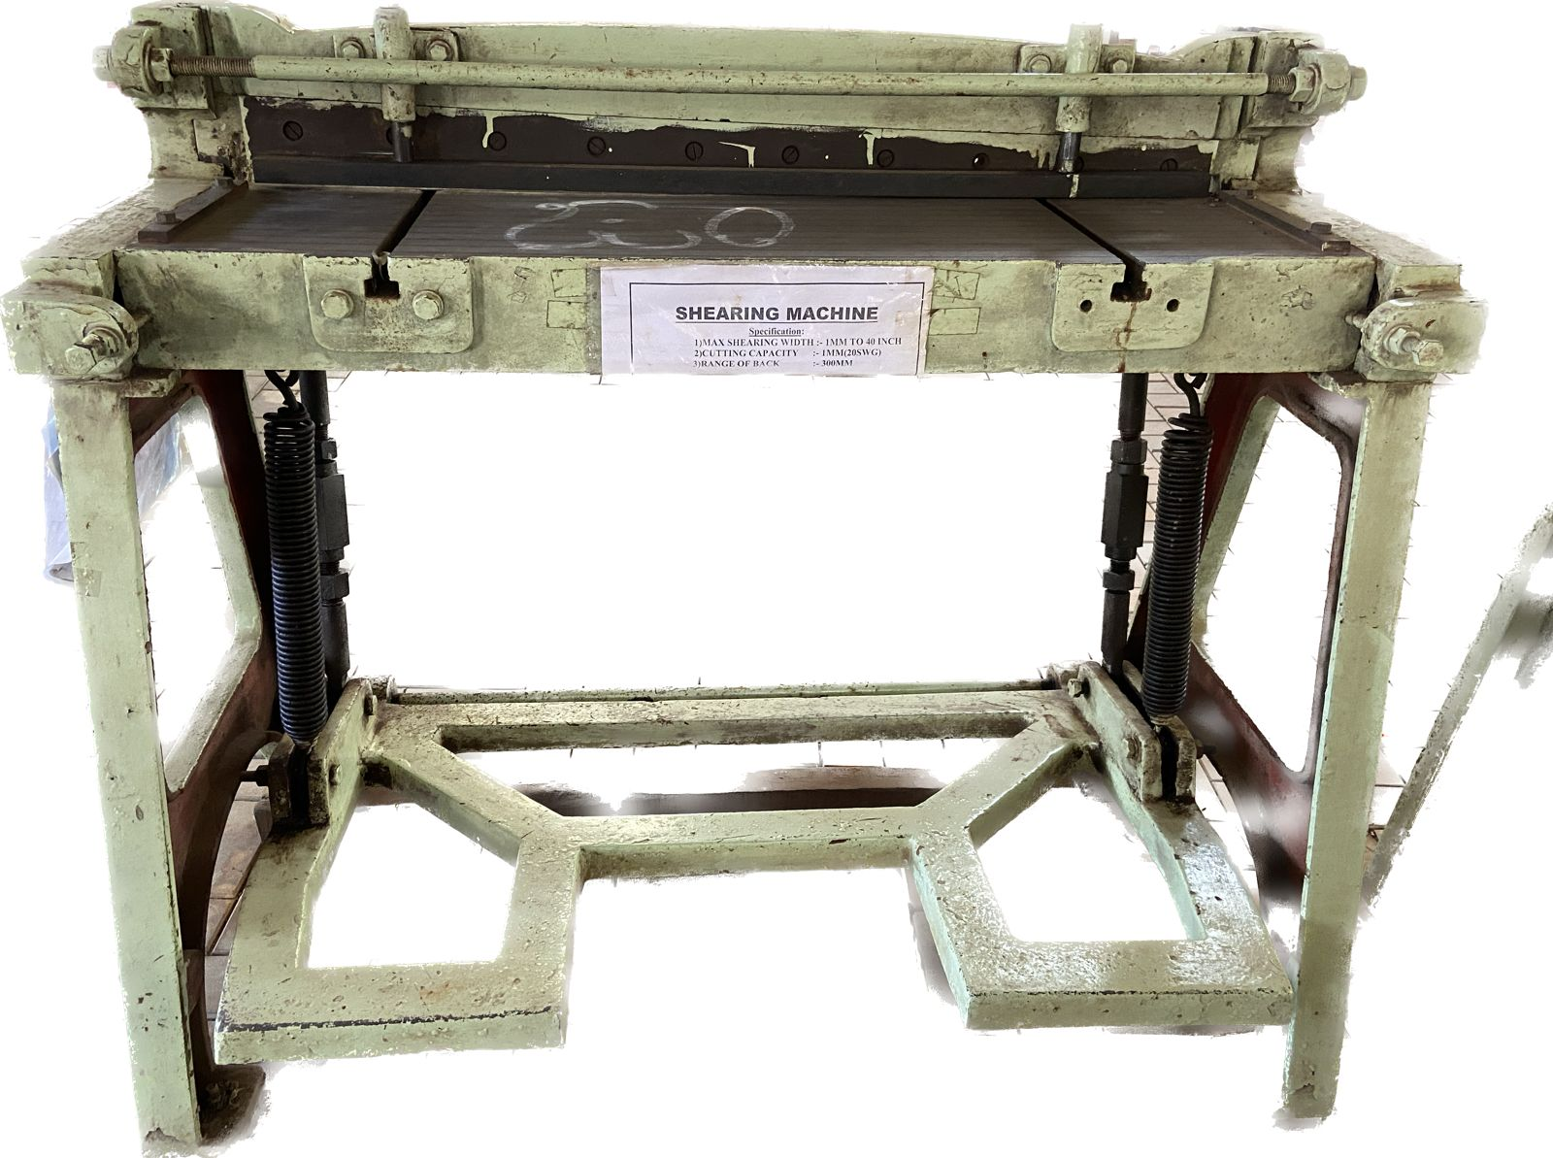

FRONT SUPPORT ROD

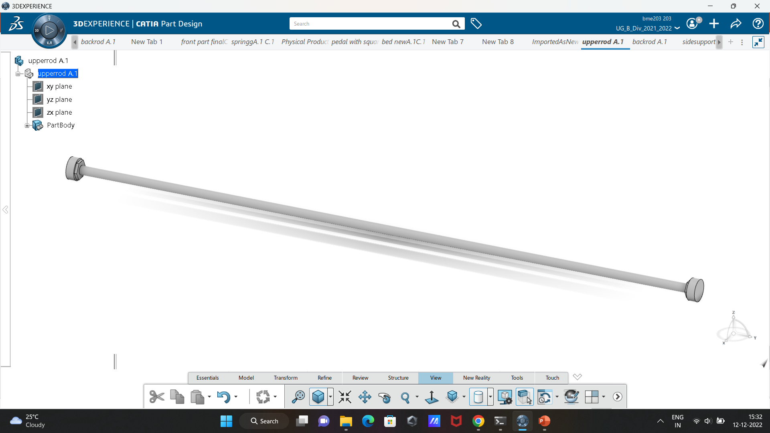

3-D Assembly

ISOMETRIC VIEW

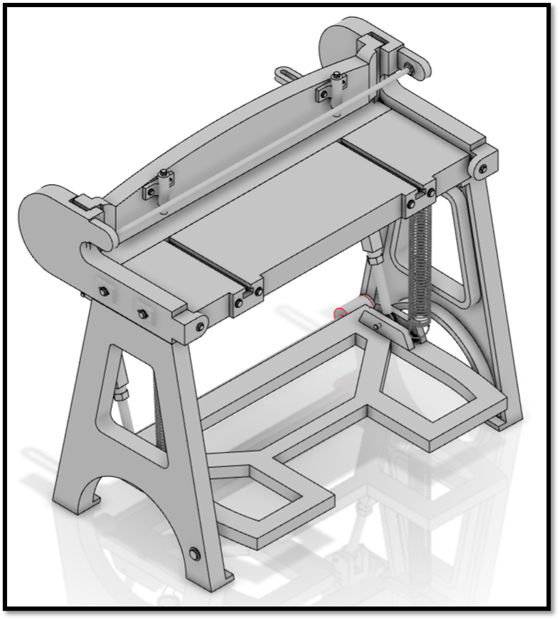

FRONT VIEW

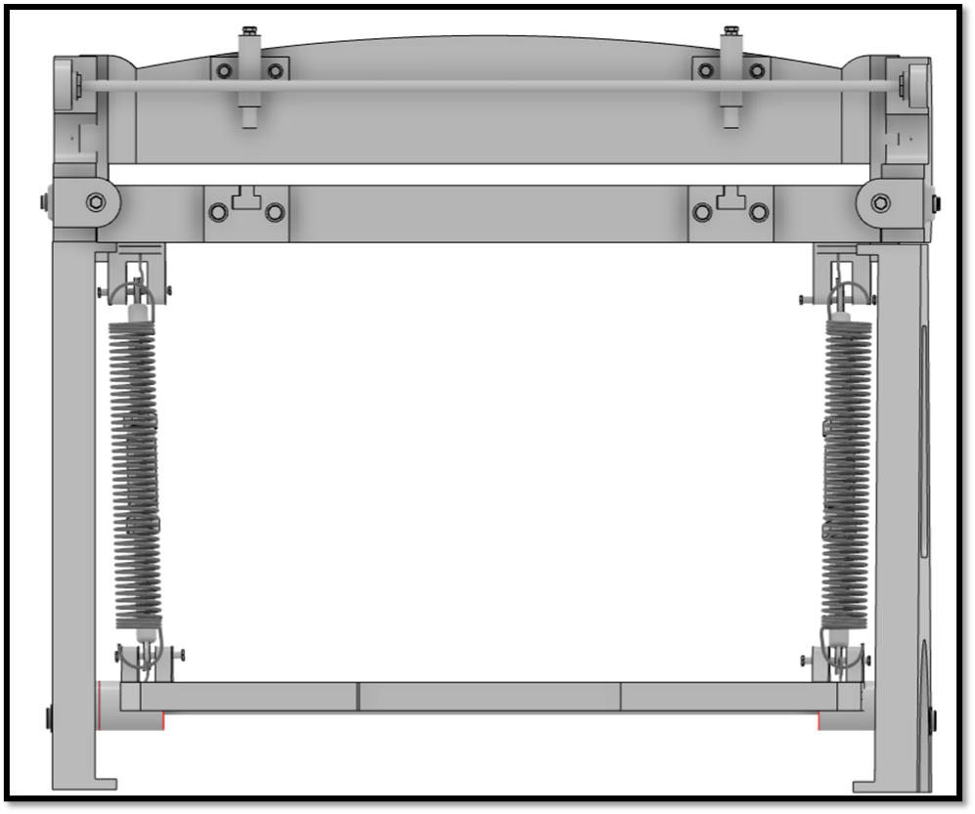

SIDE VIEW

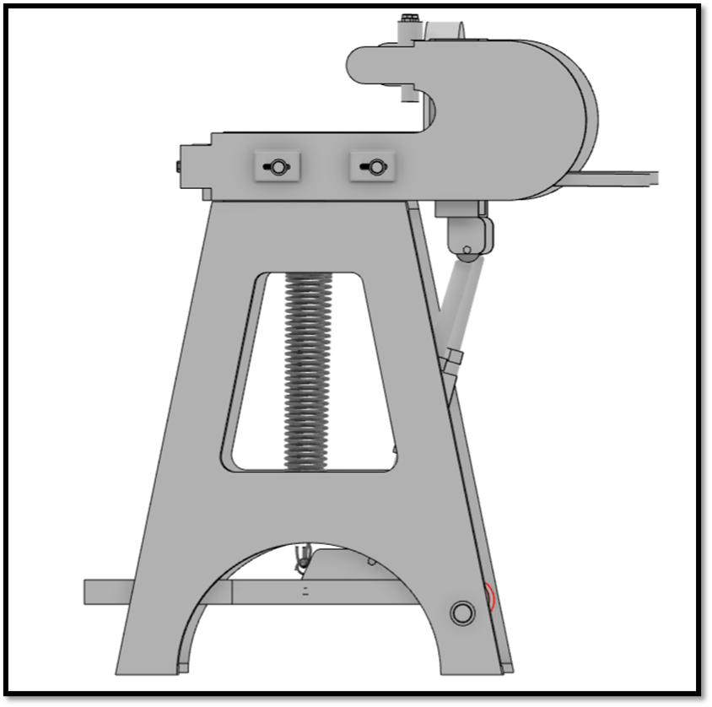

BACK VIEW

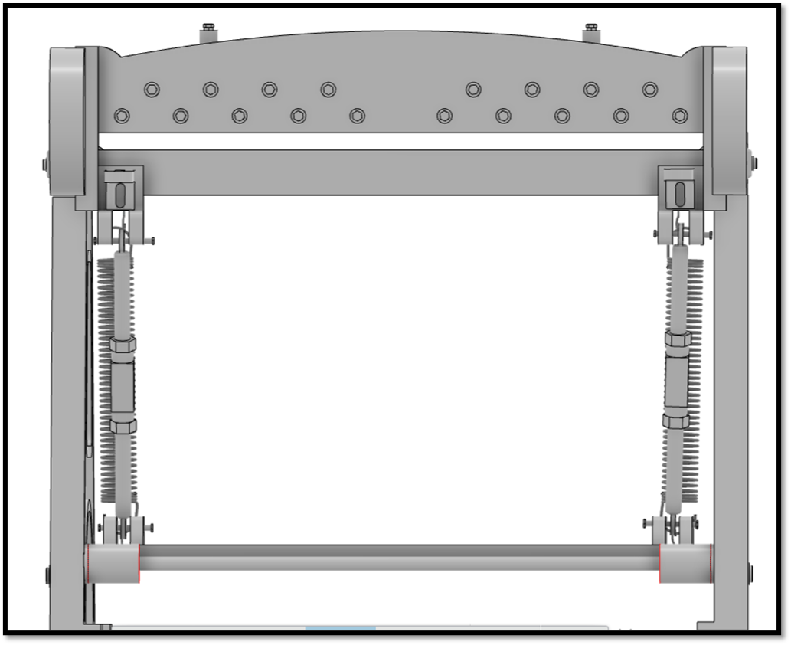

TOP VIEW

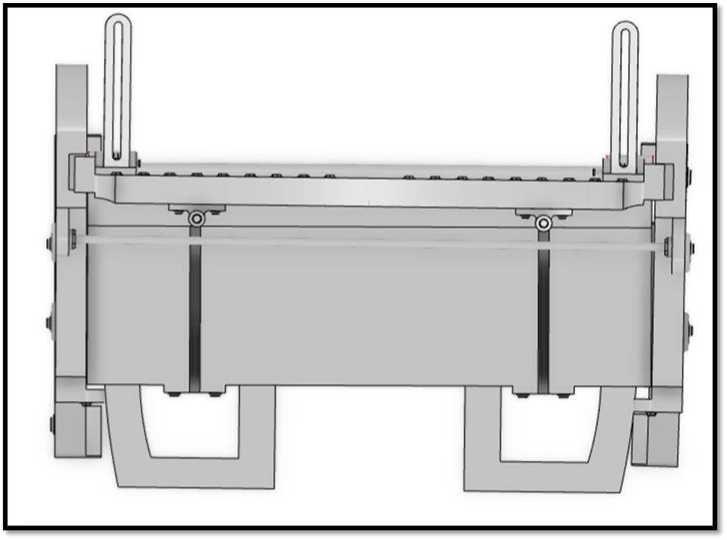

**DRAFTING**

NOTE:-All projection are according to orthographic projections.

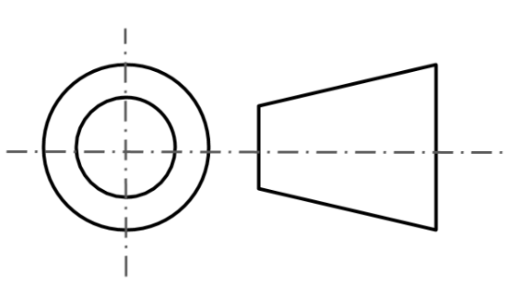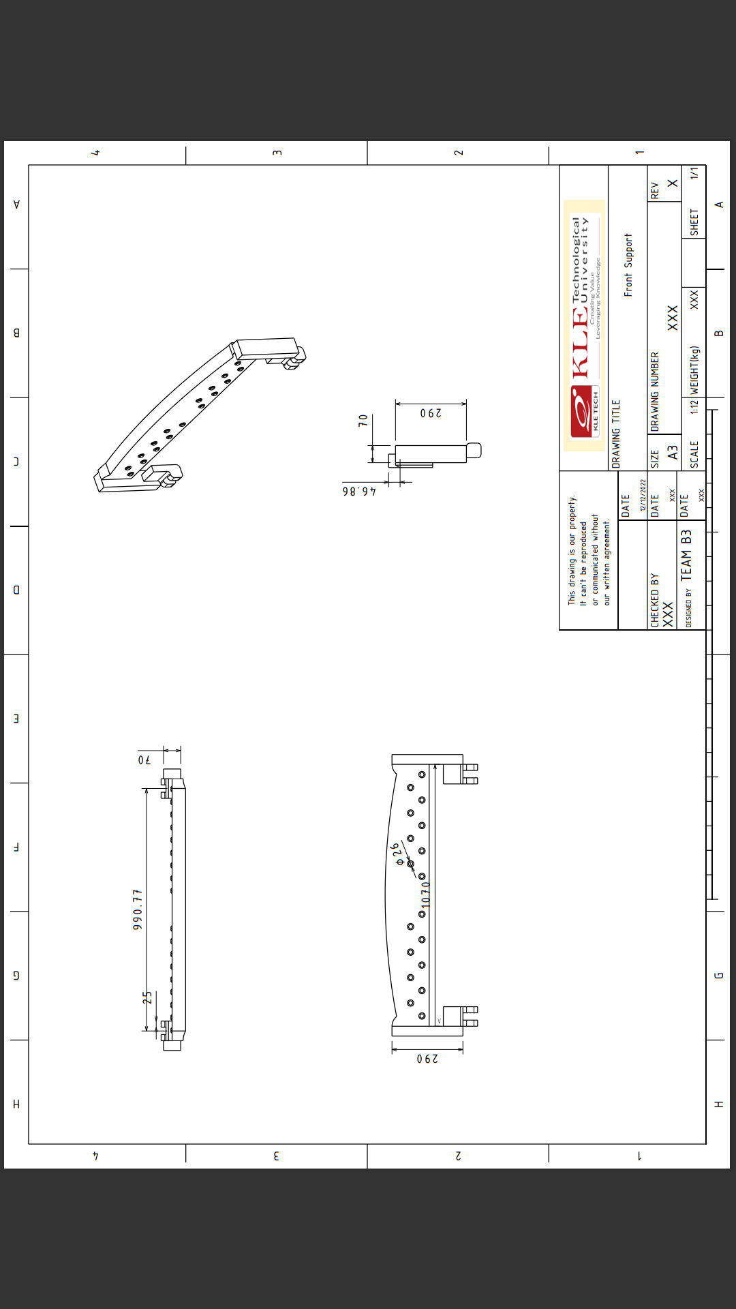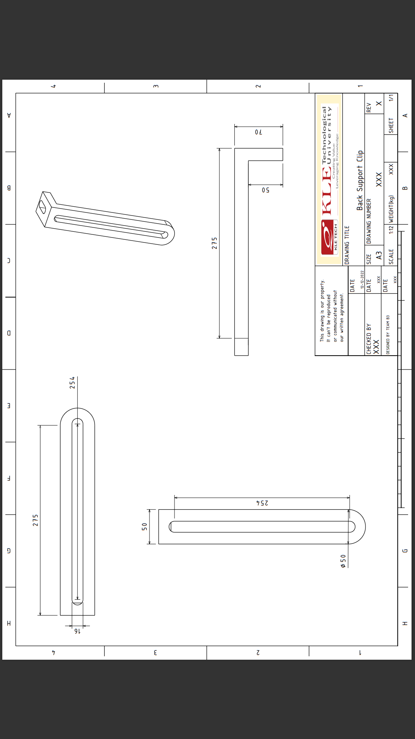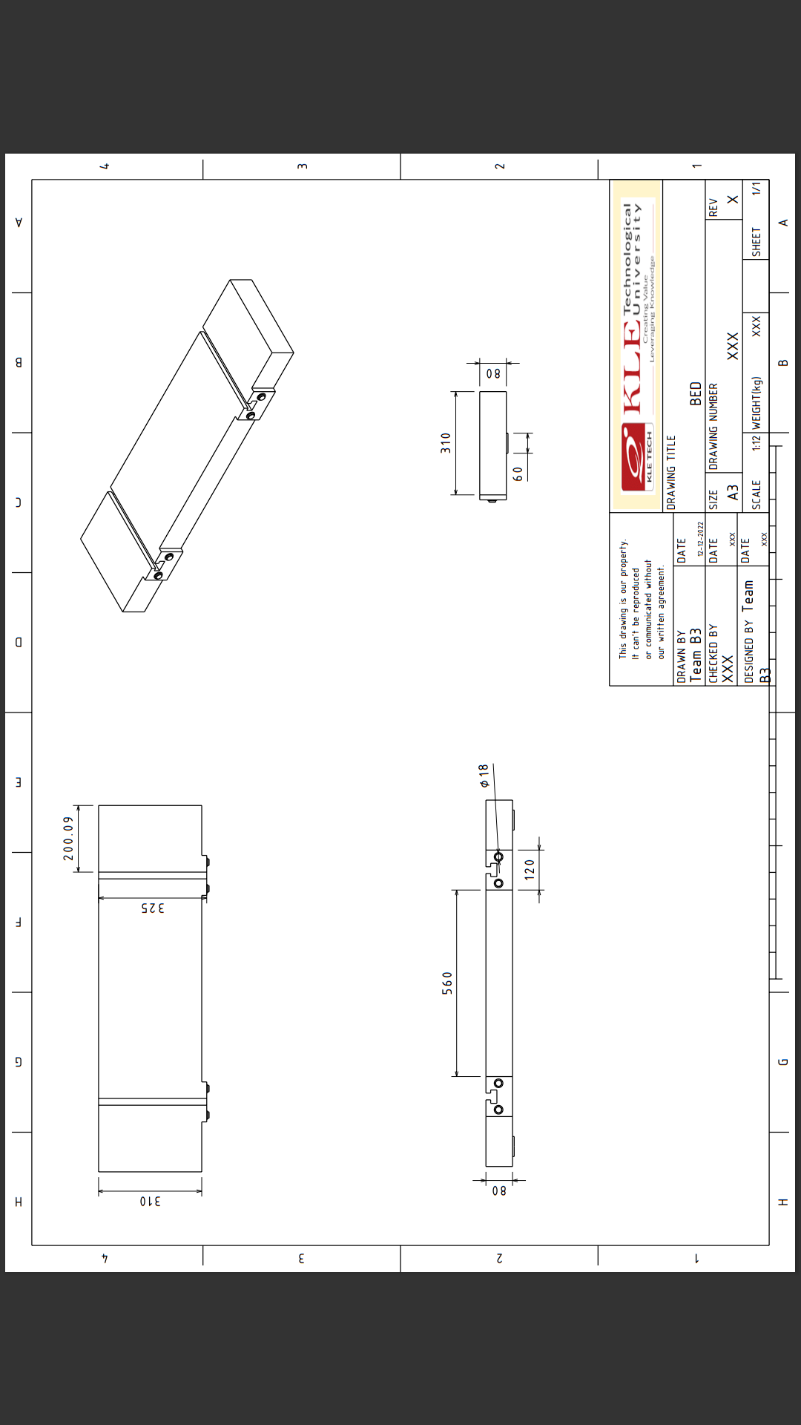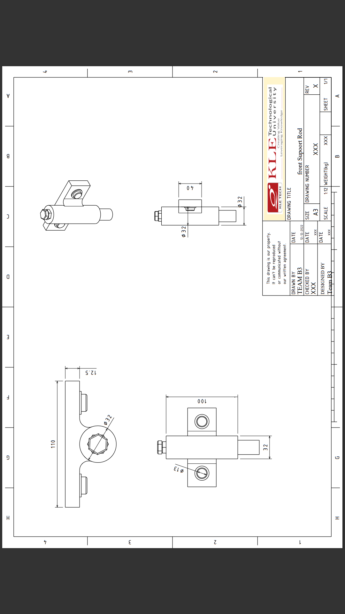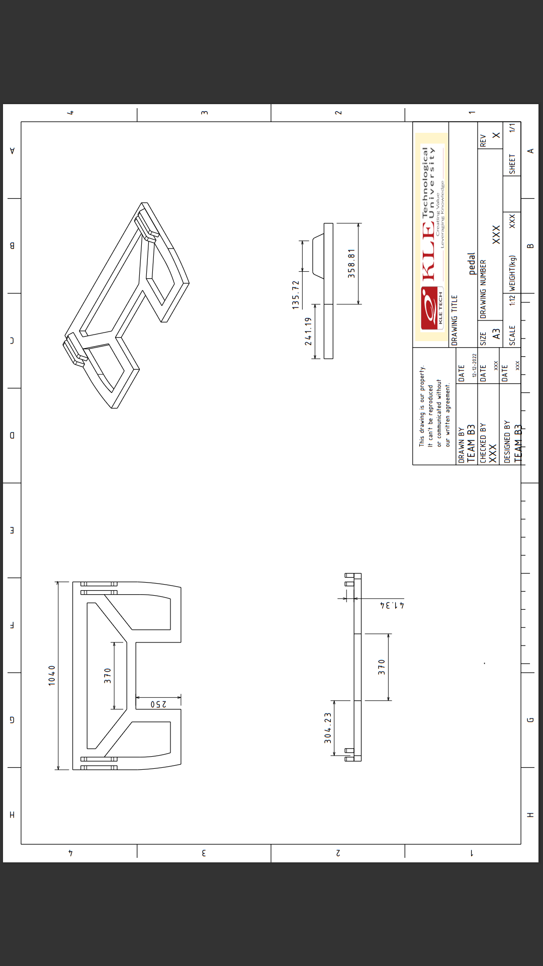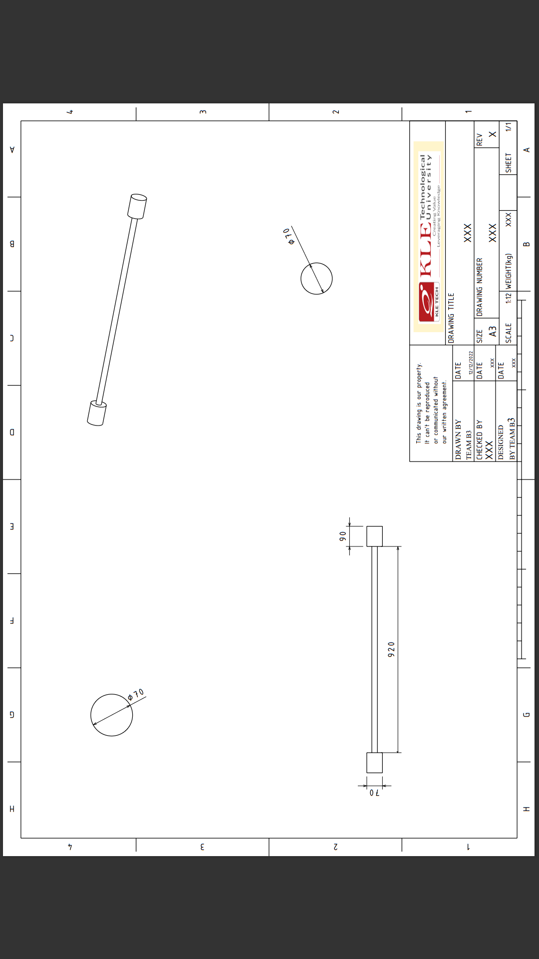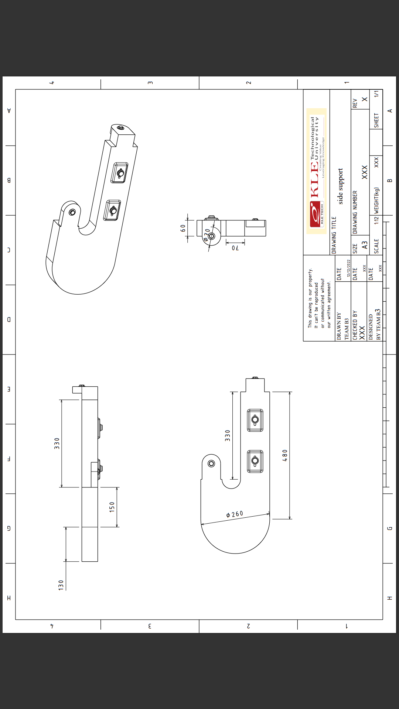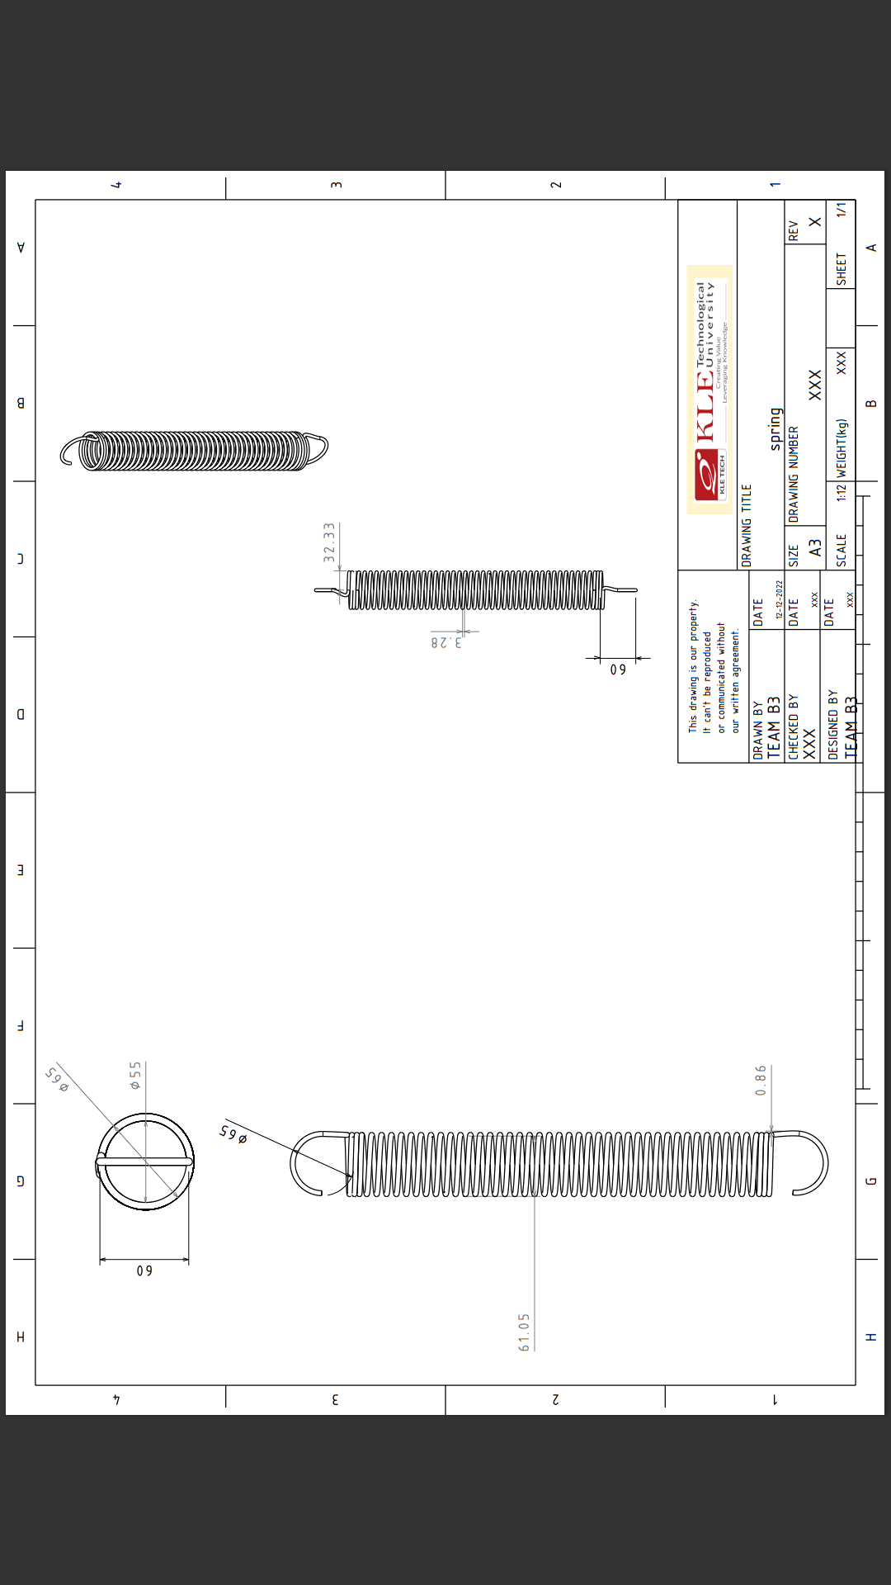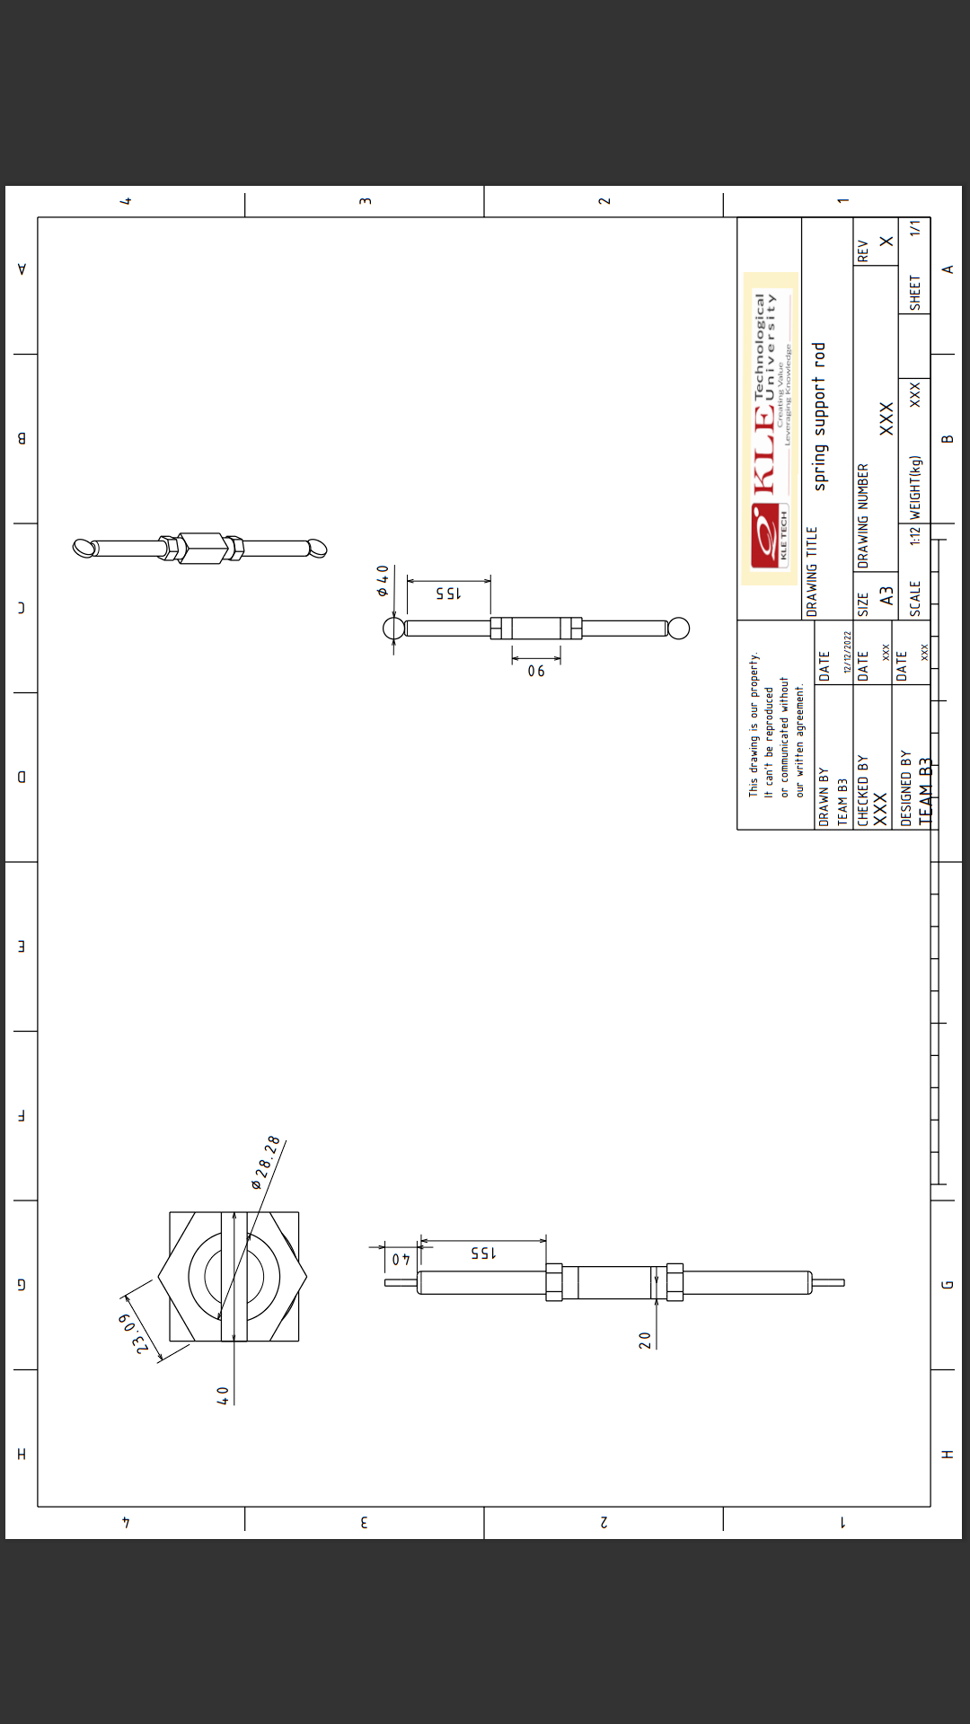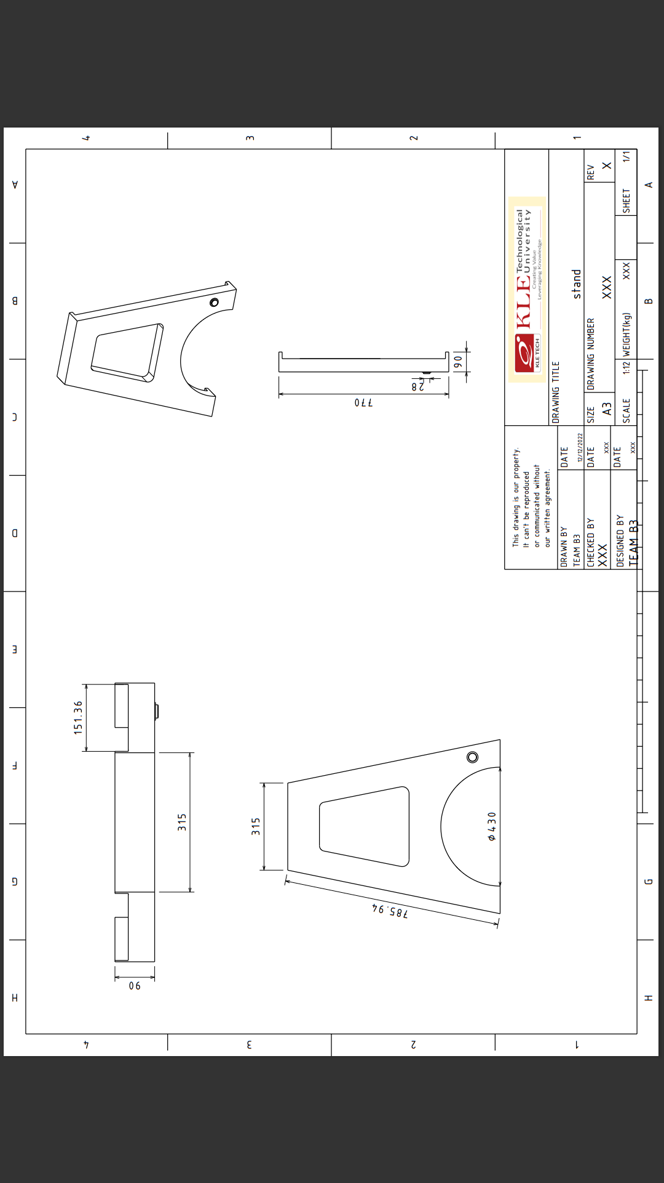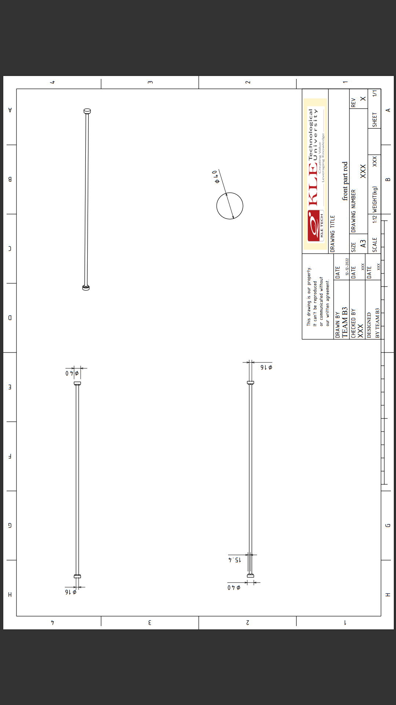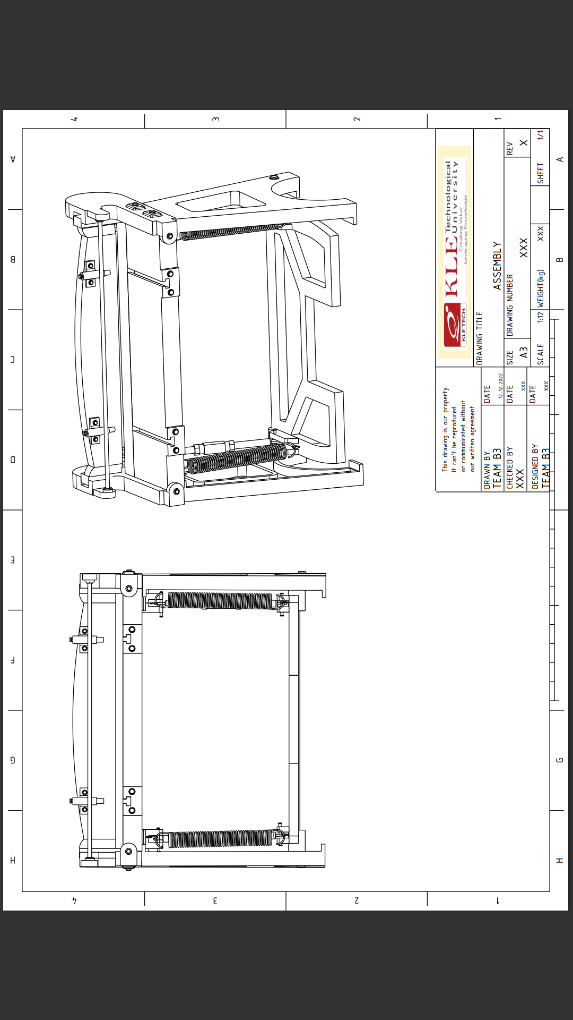

Exploded view

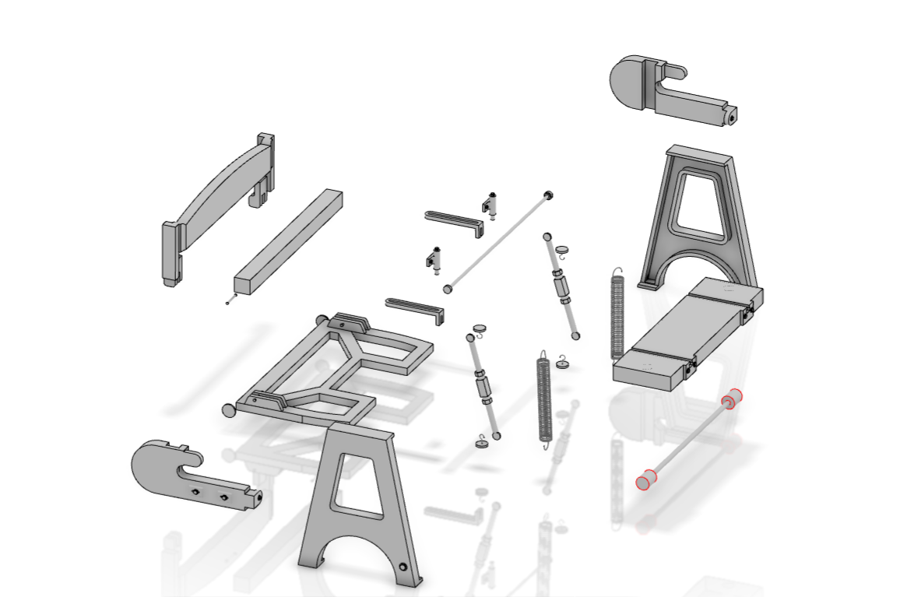

**Ballooning**

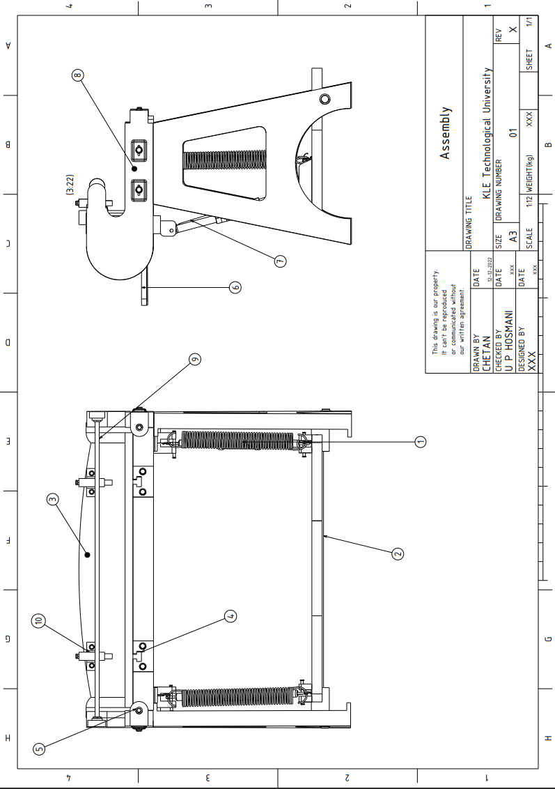

**RENDERED VIEW**

